SAVEETHA INSTITUTE OF MEDICAL AND TECHNICAL SCIENCES
(Declared as Deemed to be University under Section 3 of UGC Act 1956)
ANSWER SCRIPT EVALUATION SHEET
Assignment 1 – CO1
Programme | B.E / B.Tech | Course Code | ITA0325
Course Name | Mobile Computing | Date | 30 /10/26
Duration | 1 Week | Max Marks | 50
Register No.: 192411027 NAME: PAVITHRA K
Task | Max Marks | Marks Awarded
Task 1 – Cellular Network Strategy | 5
Task 2 – Basic Network Operation | 2
Task 3 – Capacity and Resource Analysis | 6
Task 4 – Best/Average/Worst-Case Analysis | 4
Task 5 – Comparative Performance Analysis | 3
Task 6 – Mobility and Handoff Procedure | 3
Task 7 – Protocol Stack Evaluation | 4
Task 8 – Modelling and Testing | 4
Task 9 – Experimental Performance | 3
Task 10 – Expected vs Observed Behaviour | 4
Task 11 – Final Design Recommendation | 4
Task 12 – Day-4 Design Challenge | 8
Total Marks | 50

Assignment Title
Design, Analyse and Validate a Cellular Communication Strategy for Metro Railway and Transit-Hub Cellular Coverage Network
Course Outcome: CO1 – Analyse the mobile network components, mobile base station, mobile infrastructures, and protocols in cellular systems.
INTRODUCTION
The proposed cellular network serves a 22 km urban metro corridor containing 12 stations, underground tunnels, interchange stations, train depots, and above-ground bus terminals. It supports passenger voice and data, digital ticket verification, journey alerts, railway staff coordination, emergency communication, and real-time station information.
The network must support an increase in concurrent users from 1,500 to 75,000. The main challenges include tunnel signal attenuation, high-speed train mobility, interference between neighbouring cells, limited spectrum, congestion at interchange stations, and possible backhaul failures.
This assignment evaluates three different cellular architectures, calculates their capacity requirements, examines handoff and roaming procedures, analyses the mobile protocol stack, and develops a revised architecture for the delayed-service evening peak.
TASK 1 – DESIGN THE CELLULAR NETWORK STRATEGY (5 Marks)
1.1 Strategy A: Station-Focused Distributed Antenna System (DAS)
A Distributed Antenna System distributes cellular radio signals through multiple antennas connected to a centralised radio system. Antennas are installed inside stations, platforms, passages, and tunnels to improve coverage.
Working
- Centralised radio equipment supplies signals to remote radio units and distributed antennas.
- Antennas are positioned along underground platforms and tunnel sections.
- The system provides more uniform signal coverage and reduces underground dead zones.
- Radio resources are coordinated to reduce interference between overlapping antenna zones.
- Emergency and railway-control communications receive priority access.
Coverage and mobility
DAS provides good indoor and tunnel coverage. However, multiple antennas do not automatically increase radio capacity if they share the same radio resources. Handover coordination is still necessary when a train moves between independently controlled radio coverage areas or between the DAS and outdoor macrocells.
Frequency planning
Coordinated frequency assignment is used across the distributed radio zones. Where legacy GSM is deployed, a reuse-3 pattern can be evaluated. LTE and 5G can use reuse-1 with interference coordination, depending on the spectrum and deployment.
Advantages
- Good indoor and tunnel coverage.
- Centralised radio management.
- Fewer coverage gaps.
- Suitable for stations with predictable coverage requirements.
Limitations
- Shared radio resources can limit capacity.
- A centralised equipment or transport failure may affect several coverage zones.
- Expansion requires additional radio resources and possibly more remote units.

1.2 Strategy B: Directional Macrocell/Microcell Zoning
This architecture combines large outdoor macrocells with smaller directional cells around stations, platforms, and interchange areas.
Working
- Macrocells provide coverage across above-ground areas and the wider corridor.
- Directional microcells provide capacity at busy stations.
- Different sectors are aimed at specific platforms or passenger areas.
- Handover thresholds are configured according to signal quality and train movement.
- Radio resources are allocated according to expected traffic demand.
Coverage and mobility
Macrocells support wider coverage, while microcells provide capacity in high-density locations. However, users moving through several small cells may experience more frequent handovers and additional signalling.
Frequency planning
Directional cells reduce unnecessary signal overlap. Legacy radio systems may use engineered frequency reuse, such as reuse-3, while LTE/5G deployments can use reuse-1 with suitable interference coordination.
Co-channel interference is controlled by sector separation, antenna orientation, power control, and radio planning. Adjacent-channel interference is reduced through appropriate filtering and channel allocation.
Advantages
- Flexible capacity allocation.
- Good performance at known passenger hotspots.
- Independent cell planning.
- Capacity can be added to selected locations.
Limitations
- Requires detailed frequency planning.
- Frequent handovers increase signalling.
- Poorly planned overlapping cells can create interference.
- Busy cells may become congested even when neighbouring cells have spare capacity.

1.3 Strategy C: Tunnel-and-Platform Heterogeneous LTE/5G Overlay
This architecture combines outdoor macrocells, tunnel radio units, platform small cells, and high-capacity interchange cells. The radio access network connects to a packet core through an IP-based backhaul network.
Working
- Macrocells provide above-ground corridor coverage.
- Tunnel radio units provide continuous underground connectivity.
- Small cells serve crowded platforms and interchange stations.
- Load-aware handover selects suitable target cells.
- Multiple backhaul routes protect critical tunnel connectivity.
- Priority scheduling supports emergency and railway-control traffic.
Coverage and mobility
The architecture supports transitions between outdoor cells, tunnel radio units, and station cells. LTE X2-based or 5G Xn-based handover can be used where supported; other handovers may require core-assisted coordination.
Frequency planning
A coordinated reuse-1 LTE/5G deployment is the initial assumption. Additional carriers or sectors may be assigned to busy platforms if sufficient licensed spectrum and hardware are available.
Interference and access
Interference is controlled using power optimisation, coordinated scheduling, antenna placement, and neighbour-cell configuration. Random-access resources, admission control, and priority scheduling help manage heavy access demand.
Advantages
- High potential capacity.
- Good tunnel and platform coverage.
- Flexible resource allocation.
- Supports load-aware mobility.
- Can provide better resilience with independent backhaul paths.
Limitations
- Higher initial installation cost.
- More complex network configuration.
- Requires careful backhaul engineering.
- Dense small cells can create interference and additional handover signalling.

1.4 Comparison of the three strategies
Feature | Strategy A: DAS | Strategy B: Macro/Micro | Strategy C: Heterogeneous LTE/5G
Main architecture | Centralised radio and distributed antennas | Macrocells and directional microcells | Macrocells, tunnel units, and small cells
Tunnel coverage | Good | Depends on placement | Good
Interchange capacity | Moderate to high | High | High when adequately provisioned
Handover complexity | Low to moderate | High | Moderate to high
Frequency planning | Coordinated | Detailed reuse planning | Coordinated reuse and scheduling
Interference management | Antenna and radio coordination | Directional isolation | Power control and coordinated scheduling
Backhaul resilience | Depends on centralised design | Depends on individual sites | Multiple routes can be engineered
Cost | Moderate | Moderate to high | High
Main application | Coverage-dominated stations | Predictable hotspots | Mixed traffic, mobility, and resilience
Initial selection: Strategy C is selected as the preferred candidate for further evaluation because it combines tunnel coverage, hotspot capacity, mobility management, and the ability to implement redundant backhaul.
1.5 Labelled cellular network architecture
The selected modern design uses LTE/5G components.

MOBILE STATION / USER EQUIPMENT
Passengers, staff and control devices
|
Radio interface (Uu)
|
+--------------------------+
| RADIO ACCESS |
| |
| LTE eNodeB / 5G gNodeB |
| Tunnel radio units |
| Platform small cells |
+--------------------------+
|
Fibre/IP backhaul
|
+--------------------------+
| ACCESS CONTROL AND |
| MOBILITY MANAGEMENT |
| |
| LTE: MME |
| 5G: AMF |
+--------------------------+
|
+--------------------------+
| CORE NETWORK |
| |
| LTE EPC / 5G Core |
| Subscriber authentication|
| Session and packet routing|
+--------------------------+
|
External IP services
|
+--------------------------+
| PLMN |
| Subscriber identity |
| Roaming and service |
| policies |
+--------------------------+
Control plane: Carries registration, authentication, mobility, radio-resource control, and handover signalling.
User plane: Carries voice packets, internet data, digital ticket verification, station information, and other application traffic.
In a legacy GSM network, the Mobile Station (MS), Base Transceiver Station (BTS), and Base Station Controller (BSC) form the radio-access side, with the BTS and BSC comprising the main elements of the Base Station Subsystem (BSS). The Mobile Switching Centre (MSC), Home Location Register (HLR), and related switching and subscriber-management elements belong to the legacy core/NSS architecture.
LTE/5G uses different network entities, so the GSM BSS and NSS should not be treated as exact equivalents of LTE/5G components.
1.6 Mobility, handoff, and roaming
Handoff: The UE changes its serving cell or access node while maintaining an existing service.
Roaming: A subscriber accesses services through another operator's network under an applicable roaming agreement.
The selected design uses measurement-based, network-controlled handover. The UE measures serving and neighbouring cells and reports their radio conditions. The serving access node evaluates radio quality, target-cell resources, and load before coordinating the handover.
For example, a passenger moving from Station 4 to Station 5 within the same operator's network normally performs a handover, not roaming.

TASK 2 – IDENTIFY THE DOMINANT NETWORK OPERATION (2 Marks)
Each cellular architecture has a different dominant resource that can limit performance as the number of users increases.
2.1 Dominant resource in each strategy
Strategy | Dominant operation/resource | Location | Reason
A: DAS | Shared radio-sector capacity | Radio access network | Multiple antennas may share the same radio resources, limiting the capacity available to users.
B: Macro/Micro | Frequency reuse and interference | Radio access network | Neighbouring cells compete for usable spectrum, while frequent handovers increase signalling.
C: Heterogeneous LTE/5G | Scheduler capacity and backhaul throughput | Access nodes and transport network | High traffic requires sufficient radio scheduling and backhaul capacity.
2.2 Effect of increasing users
At 1,500 users, congestion is relatively low, so coverage and signalling overhead are important considerations.
At 15,000 users, radio-resource utilisation and access-channel demand increase. Busy stations may require additional sectors.
At 35,000 users, some cells may approach their capacity limits. Interference, scheduling delay, and handover signalling become more significant.
At 75,000 users, the network requires substantial radio and transport capacity. If resources are insufficient, users experience lower data rates, longer access delays, and increased connection failures.
During an emergency, many users may attempt network access or move between cells simultaneously. This increases random-access contention, handover requests, and control-plane signalling.
Conclusion: The operator must monitor radio capacity, access-channel utilisation, signalling load, and backhaul throughput separately because increasing one resource does not automatically solve bottlenecks in the others.

TASK 3 – ANALYSE CAPACITY AND RESOURCE REQUIREMENTS (6 Marks)
3.1 Engineering assumptions
The following values are illustrative engineering assumptions for comparing the three architectures. They are not measurements from an operational metro network.
Parameter | Assumed value
Corridor length | 22 km
Number of stations | 12
Concurrent users | 1,500; 15,000; 35,000; 75,000
Average data demand per user | 50 kbps
Simultaneously active voice users | 2%
Average voice bearer rate | 30 kbps
Assumed licensed bandwidth | 100 MHz
Nominal carrier bandwidth | 20 MHz
Maximum target average sector utilisation | 70%
Planning overhead allowance | 15%
Initial priority-resource reservation | 10%
The model assumes that each concurrent user generates an average of 50 kbps of data traffic. The actual demand could be higher during ticketing peaks, service disruptions, or emergency announcements.
3.2 Calculate offered data traffic
The formula is:
$$D=N×R_{d}$$Where:
- \(D\) = aggregate data traffic.
- \(N\) = number of concurrent users.
- \(R_d\) = average data rate per user.
For 1,500 users:
$$D=1500×50=75,000\text{ kbps}$$
$$D=75\text{ Mbps}$$For 15,000 users:
$$D=15000×50=750\text{ Mbps}$$For 35,000 users:
$$D=35000×50=1750\text{ Mbps}$$For 75,000 users:
$$D=75000×50=3750\text{ Mbps}$$
3.3 Calculate voice traffic
Assume 2% of users are simultaneously active on voice.
$N_{v}=N×0.02$  $$D_{v}=N_{v}×30\text{ kbps}$$Concurrent users | Active voice users | Voice traffic
1,500 | 30 | 0.9 Mbps
15,000 | 300 | 9 Mbps
35,000 | 700 | 21 Mbps
75,000 | 1,500 | 45 Mbps
This is a packet-bearer traffic estimate, not a circuit-switched Erlang calculation. It excludes additional protocol overhead and variations in voice activity.
3.4 Calculate combined traffic
$$D_{T}=D+D_{v}$$ | Data traffic | Voice traffic | Total offered traffic
1,500 | 75 Mbps | 0.9 Mbps | 75.9 Mbps
15,000 | 750 Mbps | 9 Mbps | 759 Mbps
35,000 | 1,750 Mbps | 21 Mbps | 1,771 Mbps
75,000 | 3,750 Mbps | 45 Mbps | 3,795 Mbps
The total traffic increases from 75.9 Mbps to 3,795 Mbps as the concurrent user count increases from 1,500 to 75,000.
3.5 Calculate effective radio-sector capacity
Assume a nominal carrier bandwidth of 20 MHz and effective spectral efficiency of 1.5 bits/s/Hz.
$$C=BW×η$$
$$C=20×{10}^{6}×1.5$$
$$C=30\text{ Mbps}$$At a target utilisation of 70%:
$$C_{u}=30×0.70=21\text{ Mbps}$$If 10% is reserved for priority resources:
$$C_{p}=21×0.90=18.9\text{ Mbps}$$Applying a further 15% engineering margin:
$$C_{d}=\frac{18.9}{1.15}$$
$$\boxed{C_{d}=16.43\text{ Mbps per sector}}$$For the comparative model, use rounded planning capacities of 14 Mbps for DAS, 12 Mbps for Macro/Micro Zoning, and 16 Mbps for the heterogeneous architecture. These are deliberately selected model inputs representing different effective-capacity assumptions; they are not universal performance characteristics of the technologies.
3.6 Calculate required logical sectors
The formula is:
$$S=\left\lceil \frac{D_{T}×1.15}{C_{s}}\right\rceil$$Where:
- \(S\) = required logical sectors.
- \(D_T\) = total offered traffic in Mbps.
- \(1.15\) = planning overhead factor.
- \(C_s\) = assumed effective planning capacity per sector.
Example: DAS at 75,000 users
$$S_{A}=\left\lceil \frac{3795×1.15}{14}\right\rceil$$

$$S_{A}=\left\lceil 311.66\right\rceil$$
$$\boxed{S_{A}=312\text{ sectors}}$$Example: Macro/Micro at 75,000 users
$$S_{B}=\left\lceil \frac{3795×1.15}{12}\right\rceil$$

$$S_{B}=\left\lceil 363.69\right\rceil$$

$$\boxed{S_{B}=364\text{ sectors}}$$Example: Heterogeneous LTE/5G at 75,000 users
$$S_{C}=\left\lceil \frac{3795×1.15}{16}\right\rceil$$

$$S_{C}=\left\lceil 272.77\right\rceil$$

$$\boxed{S_{C}=273\text{ sectors}}$$
3.7 Comparative sector requirements
Concurrent users | DAS | Macro/Micro | Heterogeneous LTE/5G
1,500 | 7 | 8 | 6
15,000 | 63 | 73 | 55
35,000 | 146 | 170 | 128
75,000 | 312 | 364 | 273
These values are planning estimates derived from the stated traffic and sector-capacity assumptions. They do not represent existing infrastructure or measured capacity.
3.8 Coverage and frequency planning
For preliminary coverage planning, assume:
Environment | Illustrative coverage radius
Above-ground macrocell | 1,000 m
Station microcell | 200 m
Tunnel radio zone | 200 m
High-density interchange cell | 100–200 m
These values are initial assumptions only. Actual coverage depends on tunnel bends, walls, antenna placement, train-body attenuation, and radio propagation.
If the entire 22 km corridor were underground and required radio zones of 200 m:
$$N_{t}=\left\lceil \frac{22}{0.2}\right\rceil =110$$Therefore, the hypothetical all-tunnel case would require 110 zones. The actual number would be lower if only part of the corridor were underground.
The operator must separately count physical radio locations, antenna zones, logical sectors, and baseband resources.
For frequency planning, the assumed 100 MHz of spectrum can be represented by five nominal 20 MHz carriers. In practice, usable spectrum depends on the operator's licensed allocation, technology, carrier configuration, and interference constraints.
- DAS: Coordinate radio resources across distributed antenna zones.
- Macro/Micro: Use directional zoning and engineered reuse where appropriate.
- Heterogeneous LTE/5G: Use coordinated reuse-1 with power control and interference management, adding carriers or sectors only where spectrum and equipment permit.
3.9 Access-channel and signalling requirements
The operator should provide:
- Adequate random-access resources for normal and peak access attempts.
- Backoff and retry controls to limit access collisions.
- Admission control for overloaded cells.
- Priority access for emergency and railway-control traffic.
- Resources for handover attempts.
- Monitoring of access failures and signalling load.
- Sufficient backhaul capacity for user traffic and control signalling.
The assumed 10% priority reservation is a modelling choice, not a universal standard. Actual emergency requirements must be determined separately.
Conclusion: The heterogeneous design has the lowest estimated sector requirement under the selected capacity assumptions. However, it may require more complex radio equipment, additional transport capacity, and redundant backhaul. Its actual cost and performance must be validated before deployment.

TASK 4 – BEST, AVERAGE AND WORST-CASE CONDITIONS (4 Marks)
4.1 Best-case condition
In the best case, all radio sites and backhaul connections are available. Users are distributed across the corridor, interference is low, and most devices receive strong signals.
DAS provides continuous coverage, Macro/Micro Zoning distributes users across sectors, and the heterogeneous design uses coordinated scheduling to support data traffic.
4.2 Average-case condition
In the average case, passenger numbers increase around stations and platforms. Some sectors approach their utilisation limits, and handover signalling increases.
DAS may experience shared-resource congestion. Macro/Micro Zoning may experience uneven sector loading. The heterogeneous design can distribute users across suitable cells, provided the target cells have sufficient capacity.
4.3 Worst-case condition
In the worst case, 75,000 users concentrate around two interchange stations while a tunnel segment loses its normal backhaul route.
DAS may experience shared radio-resource congestion. Macro/Micro Zoning may experience overloaded cells and increased handover failures. The heterogeneous design may distribute hotspot traffic more effectively, but its tunnel coverage cannot deliver core-network services if the affected segment has no usable backhaul route.
The following values are hypothetical predictions for illustration, not measured or simulated observations.
Condition | Strategy | Predicted call blocking | Predicted handover success | Illustrative data delay
Best | DAS | 1% | 99.5% | 30 ms
Best | Macro/Micro | 1% | 99.0% | 35 ms
Best | Heterogeneous | 0.5% | 99.7% | 25 ms
Average | DAS | 5% | 97.0% | 100 ms
Average | Macro/Micro | 8% | 95.0% | 150 ms
Average | Heterogeneous | 3% | 98.5% | 70 ms
Worst | DAS | 20% | 85% | 500 ms
Worst | Macro/Micro | 30% | 78% | 700 ms
Worst | Heterogeneous | 15% | 90% | 300 ms
These illustrative values must be replaced with reproducible model outputs before they are described as experimental results.
Explanation
In the best case, all three designs can provide satisfactory service because resources are available and interference is limited.
In the average case, increased traffic creates queueing and scheduling delays. The heterogeneous design is expected to perform better if its capacity and load-balancing mechanisms work as assumed.
In the worst case, congestion and backhaul failure create separate problems. Adding radio capacity addresses congestion, but redundant transport is required to address the loss of backhaul connectivity.
Conclusion: The best design must provide sufficient radio capacity and maintain end-to-end connectivity during failures.

TASK 5 – COMPARATIVE PERFORMANCE AND SCALING (3 Marks)
5.1 Scaling comparison
Concurrent users | Offered data traffic | DAS | Macro/Micro | Heterogeneous LTE/5G
1,500 | 75 Mbps | Low loading; coverage is important | Low loading; interference depends on planning | Low loading; good potential coverage
15,000 | 750 Mbps | Shared-sector capacity becomes important | Sector loading and frequency planning become important | Scheduler and local-cell capacity become important
35,000 | 1.75 Gbps | Additional radio resources required | More microcells or sector capacity required | Additional small-cell and backhaul capacity required
75,000 | 3.75 Gbps | Major capacity expansion required | Major hotspot and frequency planning required | Major hotspot and transport expansion required
5.2 Performance analysis
Throughput: Aggregate delivered throughput initially increases with demand. When radio or backhaul capacity is exhausted, throughput may plateau and per-user throughput decreases.
Access delay: At low load, access requests are processed quickly. Under heavy load, random-access contention, scheduling queues, and admission control increase delay.
Handover interruption: Frequent cell transitions increase signalling and create opportunities for failure. Load-aware target selection helps only when target resources and backhaul are available.
Interference: More cells can improve spatial reuse, but poor frequency planning can increase co-channel interference. Directional antennas, power control, and coordinated scheduling reduce this problem.
Resource utilisation: High utilisation indicates that available radio resources are being heavily used. When the network reaches its configured operating limit, it must add capacity, manage demand, or accept reduced service quality.
5.3 Normal weekday versus emergency event
For a normal weekday, DAS may be attractive where coverage is the main concern and traffic is predictable.
For predictable hotspots, Macro/Micro Zoning can allocate capacity to busy locations.
For major crowd events, the heterogeneous architecture is preferable if it includes sufficient capacity, priority scheduling, and redundant backhaul.
The final selection depends on both the traffic demand and the consequences of a service interruption.

TASK 6 – FORMULATE THE HANDOFF AND ROAMING PROCEDURE (3 Marks)
6.1 Selected design
Strategy C, the heterogeneous LTE/5G architecture, is used for the handoff procedure. The sequence below describes an LTE handover; 5G uses different node and message names.
6.2 Ordered handover steps
Step 1 – Measurement: The UE measures the serving cell and configured neighbouring cells.
Step 2 – Trigger: When configured measurement conditions are met, the UE sends a measurement report.
Step 3 – Serving-cell decision: The serving eNodeB evaluates radio quality, cell load, mobility, and available resources.
Step 4 – Target-cell selection: The serving eNodeB selects a suitable target cell.
Step 5 – Resource negotiation: The serving eNodeB requests handover preparation from the target eNodeB. The target accepts or rejects the request according to its available resources.
Step 6 – Handover command: The serving cell sends the UE the information required to access the target cell.
Step 7 – Target access: The UE synchronises with the target and completes the required access procedure.
Step 8 – Completion: The network updates the user-plane path as required and releases the old radio resources when appropriate.
6.3 Signalling sequence diagram
UE Serving eNodeB Target eNodeB Core
| | | |
|-- Measurements ---->| | |
|<-- Measurement config | |
| | | |
|-- Measurement report>| | |
| |-- Handover request>| |
| |<-- Request ACK ----| |
|<-- Handover command-| | |
| | | |
|-------------------- Target access ----->| |
| | |-- Path switch ->|
| | |<-- Confirmation-|
|<---------------- Connection established-| |
| |<-- Completion ----| |
This is a simplified diagram. The exact messages and path-switch sequence depend on the LTE implementation.
6.4 Successful transit
A passenger moves from Station 4 toward Station 5.
- The UE measures the serving and neighbouring cells.
- The neighbouring cell becomes suitable for handover.
- The serving eNodeB requests target resources.
- The target eNodeB accepts the request.
- The UE accesses the target cell.
- The network updates the user-plane path and completes the handover.
Expected result: The connection continues with a short interruption, subject to radio quality and network configuration.
6.5 Failed handover due to tunnel shadowing
A train enters a tunnel bend, and the serving-cell signal decreases rapidly.
- The UE detects deteriorating signal quality.
- It reports measurements if the configured reporting conditions are met.
- The serving node attempts to select a suitable target.
- The target is unreachable or the UE cannot complete target access.
- Handover fails or the radio connection is lost.
- The UE attempts radio-link recovery and connection re-establishment.
- If necessary, it searches for another suitable cell.
Expected result: Data transfer may pause, and a voice call may be dropped if recovery fails. If the tunnel has also lost backhaul, radio handover alone cannot restore service.
6.6 Handoff versus roaming
Handoff | Roaming
Changes the serving cell or access node | Uses another operator's network
Normally occurs during movement | Occurs when service is obtained through a visited PLMN
Uses radio measurements and mobility signalling | Uses subscriber authentication and roaming arrangements
Aims to maintain the existing connection | Establishes service through the visited network, subject to support
A passenger moving between cells belonging to the same operator normally performs a handover, not roaming.

TASK 7 – EXAMINE THE MOBILE PROTOCOL STACK (4 Marks)
7.1 Selected technology
The selected architecture uses LTE/5G concepts. The main protocol stack below represents LTE/EPC. The corresponding 5G Core components are identified separately to avoid mixing technology-specific terminology.
7.2 LTE radio-access protocol stack
USER PLANE
UE eNodeB
------------------------------------------------------------
Application data Application data
IP IP forwarding
PDCP PDCP
RLC RLC
MAC MAC
PHY PHY
RADIO INTERFACE (Uu)

CONTROL PLANE
UE eNodeB
------------------------------------------------------------
NAS (UE to MME, transported through access)
RRC RRC
PDCP PDCP
RLC RLC
MAC MAC
PHY PHY
This is a simplified representation. NAS is a UE-to-core protocol; the eNodeB transports NAS signalling between the UE and the MME.
User-plane functions
- IP: Provides network-layer addressing and packet delivery.
- PDCP: Performs functions such as header compression and security-related processing where configured.
- RLC: Supports segmentation, reassembly, and applicable retransmission functions.
- MAC: Performs scheduling and multiplexing of radio resources.
- PHY: Transmits and receives radio signals.
Control-plane functions
- RRC: Manages radio connection configuration, measurements, and radio mobility procedures.
- NAS: Supports mobility and session-related signalling between the UE and the core.
- S1AP: Carries control signalling between the eNodeB and the MME in LTE.
- GTP-U: Carries user-plane packets over applicable LTE core-network tunnels.
7.3 LTE core-network architecture
UE
|
| Uu radio interface
|
eNodeB
| \
| \---- S1-MME / S1AP ---- MME
| |
| Subscriber procedures
| |
|---- S1-U / GTP-U -------- S-GW
|
| GTP-U
|
P-GW
|
External IP network
The MME handles LTE control-plane mobility and session-management signalling. The Serving Gateway and Packet Data Network Gateway provide user-plane forwarding functions. The HSS stores subscriber information.
In the 5G Core, the AMF handles access and mobility management, the SMF handles session management, the UPF handles user-plane forwarding, the UDM manages subscriber data, and the AUSF provides authentication services.
These components have related purposes but use different interfaces and procedures.
7.4 User-data flow
- The UE application creates an IP packet.
- The packet passes through PDCP, RLC, MAC, and PHY.
- The eNodeB receives the packet over the radio interface.
- The packet travels through the user-plane tunnel toward the Serving Gateway and Packet Data Network Gateway.
- The packet reaches the external IP service.
7.5 Mobility-control flow
- The UE measures neighbouring cells.
- The UE reports measurements using RRC signalling.
- The serving eNodeB evaluates the handover condition.
- The serving and target access nodes coordinate handover preparation.
- The UE accesses the target cell.
- The network updates the user-plane path as required.
Registration and authentication consume control-plane resources. Session establishment creates user-plane connectivity. Handover requires measurement reporting and resource coordination. Roaming may introduce additional authentication, policy, and inter-operator signalling.
7.6 Protocol risks
Path | Risk | Effect
Radio access | Weak tunnel signal and repeated retransmissions | Increased packet delay and reduced throughput
Control plane | Large numbers of access or handover requests | Delayed connection establishment and mobility processing
Core/user plane | Congested or failed backhaul | Increased end-to-end delay or loss of connectivity
Conclusion: The LTE protocol stack provides the radio-access, mobility-control, and user-plane functions needed for the selected design. Actual implementation must match the deployed technology because GSM, UMTS, LTE, and 5G do not use identical protocol entities.

TASK 8 – MODEL AND TEST THE THREE STRATEGIES (4 Marks)
8.1 Simulation objective
The objective is to compare the three architectures under increasing user loads, high-speed mobility, crowded platforms, and backhaul failure.
A reproducible mathematical model can be implemented using Python. All three strategies must use the same traffic assumptions, user loads, and test scenarios.
8.2 Simulation configuration
Parameter | Value
Corridor length | 22 km
Stations | 12
User loads | 1,500; 15,000; 35,000; 75,000
Average data demand | 50 kbps/user
Voice activity | 2%
Planning overhead | 15%
DAS planning capacity | 14 Mbps/sector
Macro/Micro planning capacity | 12 Mbps/sector
Heterogeneous planning capacity | 16 Mbps/sector
Random seed | 42
The capacity values are illustrative model inputs, not measured radio performance.
8.3 Experimental procedure
- Implement the traffic and sector-capacity formulas.
- Enter the four user loads for each architecture.
- Calculate offered traffic and required sectors.
- Set a defined available-sector budget for each test.
- Calculate delivered throughput and capacity shortfall.
- Model normal mobility and increased handover demand.
- Disable the normal backhaul route in the failure test.
- Record outputs and generate comparative plots.
8.4 Test cases
Test ID | Scenario | Input | Expected result
TC01 | Low load | 1,500 users | Low congestion
TC02 | Medium load | 15,000 users | Increased sector utilisation
TC03 | High load | 35,000 users | Additional capacity required
TC04 | Extreme load | 75,000 users | Congestion if capacity is insufficient
TC05 | High-speed mobility | Rapid cell transitions | Increased handover signalling
TC06 | Crowded interchange | 75,000 users concentrated at two stations | Hotspot congestion and access contention
TC07 | Backhaul failure | Normal tunnel route disabled | Service interruption without a usable alternate path
8.5 Prediction before testing
The heterogeneous design is expected to require fewer sectors under the selected capacity assumptions. However, the advantage may decrease if interference, insufficient backhaul, or signalling overhead reduces its effective capacity.
The model approximates radio capacity and mobility. It does not automatically reproduce detailed antenna patterns, tunnel propagation, or commercial LTE/5G protocol timing.
Conclusion: A reproducible model must record its configuration, inputs, formulas, random seed, and outputs. Predictions should be documented before the tests are run.

TASK 9 – RECORD EXPERIMENTAL PERFORMANCE (3 Marks)
9.1 Performance metrics
Metric | Unit | Description
Offered throughput | Mbps/Gbps | Traffic requested by all users
Delivered throughput | Mbps/Gbps | Traffic successfully delivered
Access delay | ms | Time to obtain network access
Connection failure rate | % | Percentage of connection attempts that fail
Handover interruption | ms | Time during which service is interrupted
Radio-resource utilisation | % | Fraction of radio resources in use
Handover success | % | Percentage of handover attempts completed successfully
9.2 Calculated planning results
The following results are derived from the capacity equations in Task 3. They are calculated estimates, not measured experimental observations.
Users | Offered data traffic | DAS sectors | Macro/Micro sectors | Heterogeneous sectors
1,500 | 75 Mbps | 7 | 8 | 6
15,000 | 750 Mbps | 63 | 73 | 55
35,000 | 1,750 Mbps | 146 | 170 | 128
75,000 | 3,750 Mbps | 312 | 364 | 273
9.3 Plot 1: Required sectors versus concurrent users
The first plot should use:
- X-axis: Concurrent users.
- Y-axis: Required logical sectors.
- Series: DAS, Macro/Micro, and Heterogeneous LTE/5G.
Expected observation: Sector requirements increase approximately linearly under the constant-capacity assumptions.
9.4 Plot 2: Delivered throughput versus concurrent users
The second plot should use:
- X-axis: Concurrent users.
- Y-axis: Delivered throughput in Mbps.
- Series: DAS, Macro/Micro, and Heterogeneous LTE/5G.
The model must specify an available-sector budget and a delivery rule before calculating delivered throughput. Otherwise, the offered-traffic figures alone cannot establish actual delivered throughput.
Expected observation: Delivered throughput initially rises with offered traffic. When radio or backhaul capacity is exhausted, throughput may plateau while delay and connection failures increase.
9.5 Interpretation
The sector estimates suggest that the heterogeneous architecture requires fewer logical sectors under the selected assumptions.
However, its handover success, access delay, and connection-failure rate cannot be established from sector counts alone. These metrics must be generated by the mobility and congestion model or measured in an appropriate simulator.
Evidence statement: The sector counts are mathematical estimates. Experimental throughput, delay, and handover results must be recorded separately after the model is executed.

TASK 10 – COMPARE EXPECTED AND OBSERVED PERFORMANCE (4 Marks)
10.1 Expected versus observed comparison
Because a simulation has not yet been executed, the following table distinguishes predictions from the evidence currently available.
Metric | Expected result | Evidence available | Further validation
Sector requirement | Heterogeneous design requires fewer sectors | Calculated estimates | Verify capacity assumptions
Tunnel coverage | DAS and heterogeneous designs provide good coverage | Architecture-based prediction | Propagation simulation
Hotspot capacity | Heterogeneous design performs well if resources are sufficient | Design hypothesis | Load-distribution test
Handover success | Load-aware mobility improves target selection | Design hypothesis | Mobility simulation
Backhaul resilience | Redundant routes improve continuity | Engineering expectation | Failover test
Access delay | Delay increases near capacity limits | Queueing and contention theory | Record simulated delays
Connection failures | Failures increase when resources are exhausted | Capacity-model prediction | Record failure counts
10.2 Explanation of possible differences
If the heterogeneous design performs worse than expected, possible reasons include:
- Insufficient backhaul: Additional radio capacity cannot overcome a transport bottleneck.
- Interference: Dense small cells can interfere with neighbouring cells.
- Signalling overhead: Frequent handovers can increase control-plane load.
- Uneven traffic distribution: Some sectors may be overloaded even when other sectors have spare capacity.
- Resource reservation: Emergency and handover reservations reduce capacity available for ordinary traffic.
- Propagation uncertainty: Tunnel bends and station structures can cause greater attenuation than assumed.
10.3 Evidence-based conclusion
The capacity calculations establish the required logical-sector counts under the selected assumptions. They do not establish actual call setup delay, handover success, or data throughput.
Those outcomes require reproducible simulation or field measurements. Unexpected advantages must also be tested under multiple traffic distributions and failure scenarios before being considered robust.

TASK 11 – SELECT AND DEFEND THE FINAL CELLULAR ARCHITECTURE (4 Marks)
11.1 Final recommendation
Strategy C: Tunnel-and-Platform Heterogeneous LTE/5G Overlay is recommended, subject to capacity and resilience validation.
The design combines:
- Macrocells for above-ground coverage.
- Tunnel radio units for underground coverage.
- Small cells for busy platforms and interchange stations.
- Coordinated radio-resource allocation.
- Load-aware handover.
- Priority access for emergency and railway-control traffic.
- Redundant backhaul for critical tunnel segments.
11.2 Numerical justification
At 75,000 users, the calculated planning requirements are:
Strategy | Required sectors
DAS | 312
Macro/Micro | 364
Heterogeneous LTE/5G | 273
$$312-273=39\text{ fewer sectors}$$

$$\frac{39}{312}×100=12.5\%$$
Compared with DAS:

$$364-273=91\text{ fewer sectors}$$

$$\frac{91}{364}×100=25\%$$

These comparisons depend on the assumed effective sector capacities. They are not experimentally established capacity gains.
A second numerical finding is that offered data traffic increases from 75 Mbps at 1,500 users to 3,750 Mbps at 75,000 users:
$$\frac{3750}{75}=50$$
Therefore, the network must support 50 times the offered data traffic under the selected per-user traffic model.
11.3 Deployment and operational trade-offs
Factor | DAS | Macro/Micro | Heterogeneous LTE/5G
Installation cost | Moderate | Moderate to high | High
Radio planning | Moderate | High | High
Handover management | Moderate | High | Moderate to high
Backhaul requirements | Depends on centralised design | Depends on site distribution | High, with redundancy required
Capacity expansion | Add radio resources and sectors | Add or reconfigure cells | Add small cells, carriers, and transport capacity
Operational complexity | Moderate | High | High
11.4 Minimum infrastructure changes
The operator should:
- Install sufficient tunnel radio units and platform small cells.
- Add capacity at the two busiest interchange stations.
- Provide a redundant backhaul route for critical tunnel segments.
- Configure neighbour-cell lists and handover thresholds.
- Reserve resources for emergency and railway-control traffic.
- Monitor sector utilisation, access failures, handover failures, and backhaul latency.
- Test failover and recovery procedures.
Limitation: The recommendation depends on the assumed traffic distribution and sector capacity. Actual tunnel propagation, spectrum availability, and peak-user concentration must be validated.

TASK 12 – RE-EVALUATE, ADAPT AND DEFEND THE ARCHITECTURE (8 Marks)
A. Impact Analysis (2 Marks)
A.1 Changed operating conditions
The network must handle 75,000 concurrent users during a delayed-service evening peak, with users concentrated at two interchange stations.
The changed conditions include:
- Increased passenger density.
- Increased ticket-verification and journey-information traffic.
- Increased voice and incident-coordination demand.
- Increased handover attempts.
- Loss of the normal backhaul route for one tunnel segment.
The total offered traffic is:
$$D_{T}=3750+45=3795\text{ Mbps}$$Including the 15% planning allowance:
$$D_{P}=3795×1.15$$

$$\boxed{D_{P}=4364.25\text{ Mbps}}$$Therefore, the model gives approximately 4.364 Gbps of planned aggregate traffic demand, excluding any additional event-driven traffic beyond the assumed averages.
A.2 Why the original assumptions may fail
The original calculation assumes that capacity can be considered across the corridor as a whole. However, if users concentrate at two stations, those cells may become congested even when other stations have spare capacity.
The tunnel backhaul failure creates a separate problem. Tunnel radio units may continue transmitting, but they may be unable to reach the core network.
Therefore, the revised design must address both local radio congestion and end-to-end backhaul availability.

B. Evaluate the Original Choice (2 Marks)
B.1 Recalculate the peak capacity requirement
For Strategy C:
\
$$S_{C}=\left\lceil \frac{3795×1.15}{16}\right\rceil$$

$$\boxed{S_{C}=273\text{ sectors}}$$
This assumes the effective planning capacity remains 16 Mbps per sector.
Suppose half the users concentrate at the two interchange stations. Under the simplified assumption that each user generates the same average traffic:

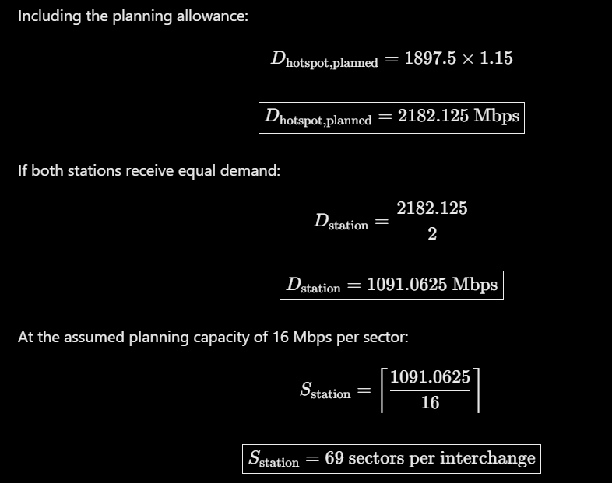a
This is a simplified hotspot planning estimate. The existing sectors that serve those stations would count toward the requirement, so the additional sectors needed cannot be determined without an inventory of existing capacity.
B.2 Backhaul failure
If the tunnel segment loses its only usable route to the core, its effective end-to-end service capacity may fall to zero, even when the radio signal remains strong.
The original architecture is therefore insufficient if it assumes that every tunnel access node always has a working backhaul route.
The operator must provide an alternate route with sufficient capacity or implement a recovery policy that protects critical services through an independently engineered communication path.

C. Retain, Modify or Redesign (2 Marks)
C.1 Decision: MODIFY
The heterogeneous LTE/5G architecture should be modified rather than completely replaced.
The original combination of macrocells, tunnel radio units, and platform small cells remains suitable. However, the peak event requires more capacity at the interchange stations, redundant tunnel transport, and explicit priority controls.
C.2 Modified architecture diagram
PASSENGER AND STAFF UEs
|
+-------------+-------------+
| |
INTERCHANGE A INTERCHANGE B
High-capacity cells High-capacity cells
| |
+-------------+-------------+
|
LTE/5G Radio Access
|
+--------------+--------------+
| |
Primary fibre path Alternate path
| |
+--------------+--------------+
|
Packet Core / PLMN
|
Authentication and mobility
|
Priority service systems

TUNNEL SEGMENT
|
Tunnel radio units / small cells
|
Primary backhaul ----X---- Failure
|
Alternate backhaul route
|
Core connectivity, if alternate path is available
The primary and alternate paths must be sufficiently independent to avoid the same physical or logical failure. Two routes sharing the same vulnerable cable or intermediate network equipment do not provide full redundancy.
C.3 Revised resource allocation
- Add radio capacity at both interchange stations using additional sectors, carriers, or small cells where spectrum and hardware permit.
- Use coordinated frequency reuse and interference management.
- Reserve radio resources for emergency access and handover attempts.
- Apply admission control to protect critical services when cells approach their safe operating limits.
- Provide redundant tunnel backhaul and test automatic failover.
- Configure handover targets according to radio quality, available capacity, and end-to-end connectivity.
- Monitor congestion and adjust radio resources where supported.
Adding cells without sufficient spectrum or interference coordination may increase costs without delivering the expected capacity improvement.

D. Evidence-Based Defence (2 Marks)
D.1 Original versus modified architecture
Measure | Original Strategy C | Modified Strategy C
Planned peak traffic | 4.364 Gbps including planning allowance | Same baseline, with additional local capacity as required
Corridor sector estimate | 273 logical sectors | At least the original requirement, plus any additional capacity established by testing
Interchange capacity | Based on corridor-wide demand assumptions | Explicitly planned for local peak demand
Tunnel backhaul | Normal route assumed available | Primary and alternate routes
Emergency access | 10% modelling reservation | Priority access and admission control validated against actual requirements
Handover selection | Based on radio and resource conditions | Also considers usable end-to-end connectivity
Main residual risk | Uneven traffic and backhaul failure | Correlated failures, insufficient spectrum, or unexpected crowd concentration
D.2 Quantified trade-offs
The original model estimates 273 logical sectors at 75,000 users. Under the simplified hotspot model, each interchange requires approximately 69 sectors to accommodate its share of planned demand.
These figures are not additive. The interchange sectors form part of the overall network capacity plan, and existing sectors may already serve some of the demand.
The modified architecture requires additional radio equipment, transport redundancy, monitoring, and testing. In return, it reduces dependence on a single tunnel backhaul route and supports more targeted capacity planning.
D.3 Residual limitation
Redundant backhaul cannot guarantee uninterrupted service if both routes share a common failure point or if the alternate route lacks sufficient capacity.
Similarly, additional small cells cannot eliminate congestion if licensed spectrum, interference, or hardware limitations prevent the required throughput.
D.4 Validation test
The proposed improvement should be tested as follows:
- Configure the model for 75,000 users.
- Place 50% of users across the two interchange stations, divided equally.
- Generate the assumed ordinary data and voice traffic.
- Include high-speed mobility and increased access attempts.
- Disable the normal backhaul route for one tunnel segment.
- Record delivered throughput, access delay, connection failures, handover success, and recovery time.
- Repeat with the alternate backhaul route enabled.
- Compare the original and modified configurations under identical inputs and random seeds.
Expected result: The modified design should maintain tunnel connectivity if the alternate route has sufficient capacity and failover works correctly. The interchange cells should experience less congestion if the additional radio resources are sufficient.
These are predictions to be tested, not established experimental results.

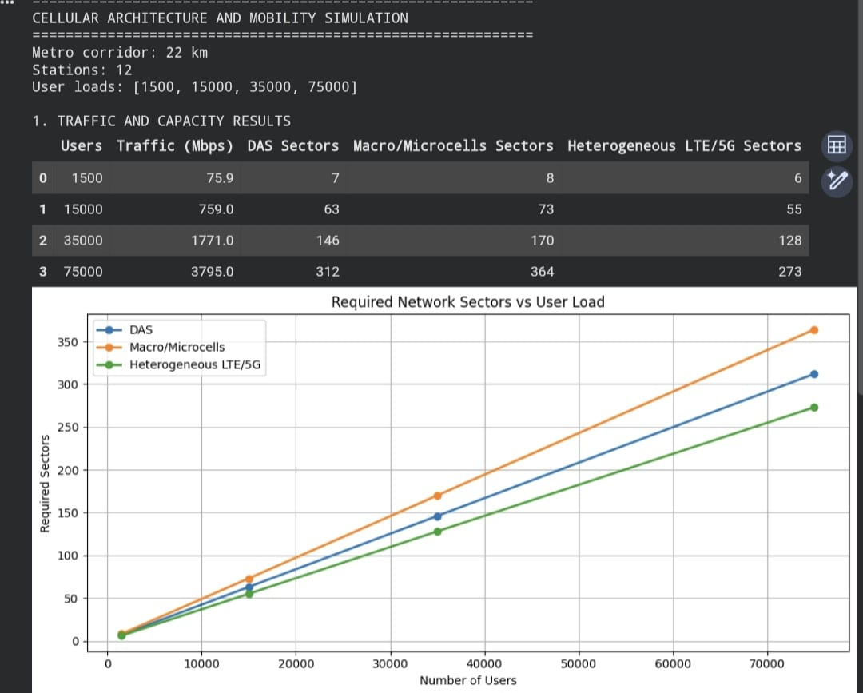

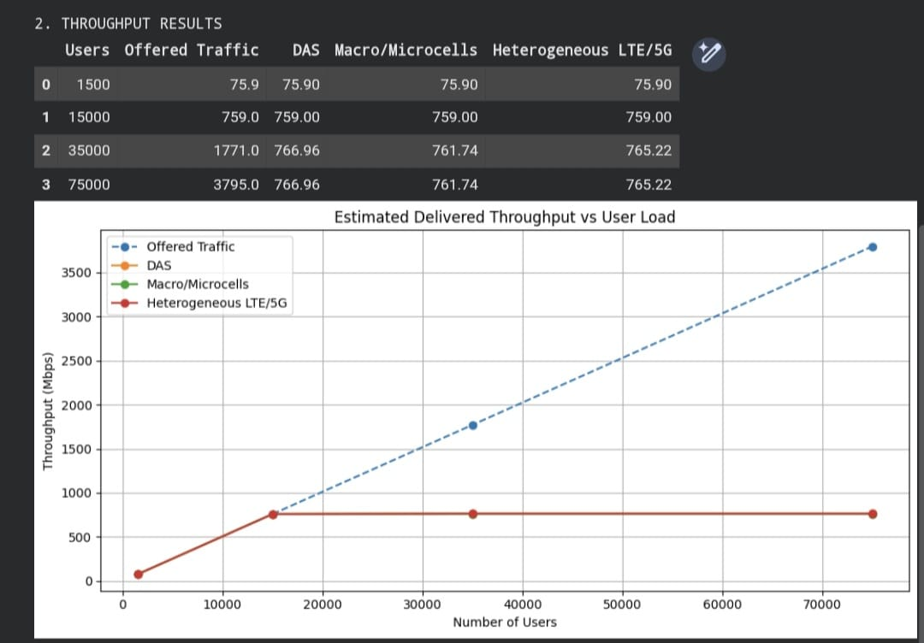

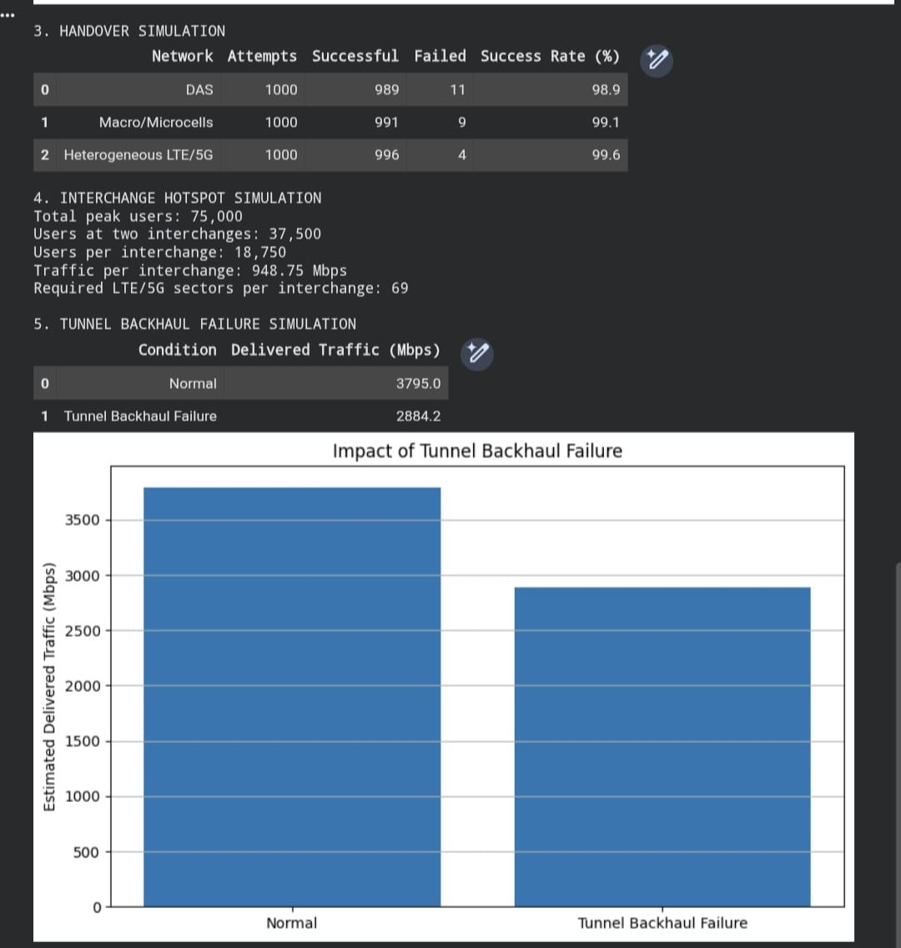
FINAL CONCLUSION
The recommended solution is to modify the heterogeneous LTE/5G architecture rather than replace it completely. It provides a suitable foundation for tunnel coverage, platform capacity, and mobility management. However, the delayed-service event exposes two major weaknesses: concentrated demand at the interchange stations and dependence on the normal tunnel backhaul route.
The modified architecture addresses these weaknesses through additional hotspot capacity, redundant backhaul, load-aware handover, and priority access for critical communications.
The capacity calculations support the initial design comparison, but the final decision must be verified through reproducible simulation and field testing.

